**DAILY TASK**

**Use logistic regression to predict whether a patient has heart disease based on various health indicators.**

**Dataset:**

The dataset contains information about patients, including various health indicators such as age, gender, cholesterol levels, blood pressure, etc. (You can use a dataset like the Heart Disease UCI dataset or any similar dataset).

1. Load the dataset.
2. Handle missing values appropriately.
3. Encode categorical variables (e.g., gender) using one-hot encoding.
4. Scale numerical features (e.g., age, cholesterol, blood pressure).
5. Perform basic exploratory data analysis to understand the distribution of the data and relationships between variables.
6. Visualize correlations between features and the target variable (presence or absence of heart disease)
7. Split the data into training and testing sets (e.g., 80% training, 20% testing).
8. Train a logistic regression model on the training set.
9. Ensure that you include regularization (L1, L2, or both) in your model to prevent overfitting.
10. Evaluate the model using accuracy, precision, recall, F1-score, and ROC-AUC on the test set.
11. Plot the ROC curve and calculate the AUC value.
12. Interpret the coefficients of the logistic regression model.
13. Calculate the odds ratios for the features and explain what they imply about the likelihood of having heart disease.

**REQUIREMENTS:**

1. PC / Laptop
2. VS Code / Jupyter Notebook
3. Bowser

**PROCEDURE:**

1. Open vs code
2. Create a folder
3. Create task.py in the folder
4. Copy the csv file to the folder
5. Write code in task.py

**Import Required Libraries**

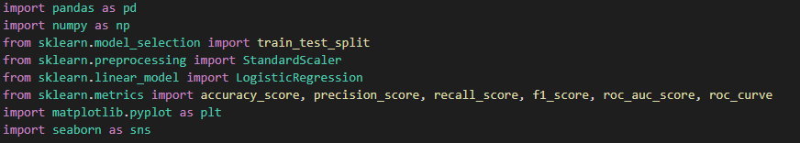

**Load the CSV Dataset**

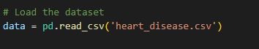

**Handle Missing Values**

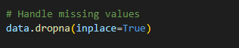

**Encode Categorical Variables**

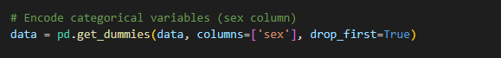

**Scale Numerical Features**

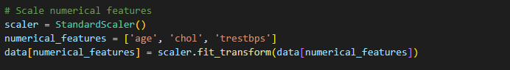

**Exploratory Data Analysis**

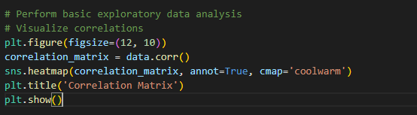

**Split the Data**

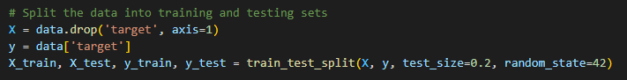

**Train the Logistic Regression Model**

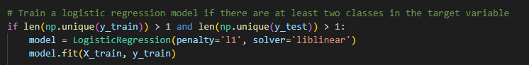

**Evaluate the Model**

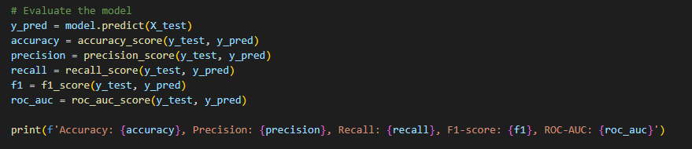

**Plot the ROC Curve**

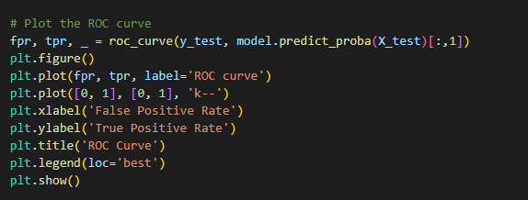

**Interpret the Coefficients**



**Calculate Odds Ratios**

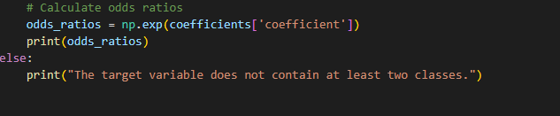

1. Run the file using “python task.py”

**OUTPUT:**

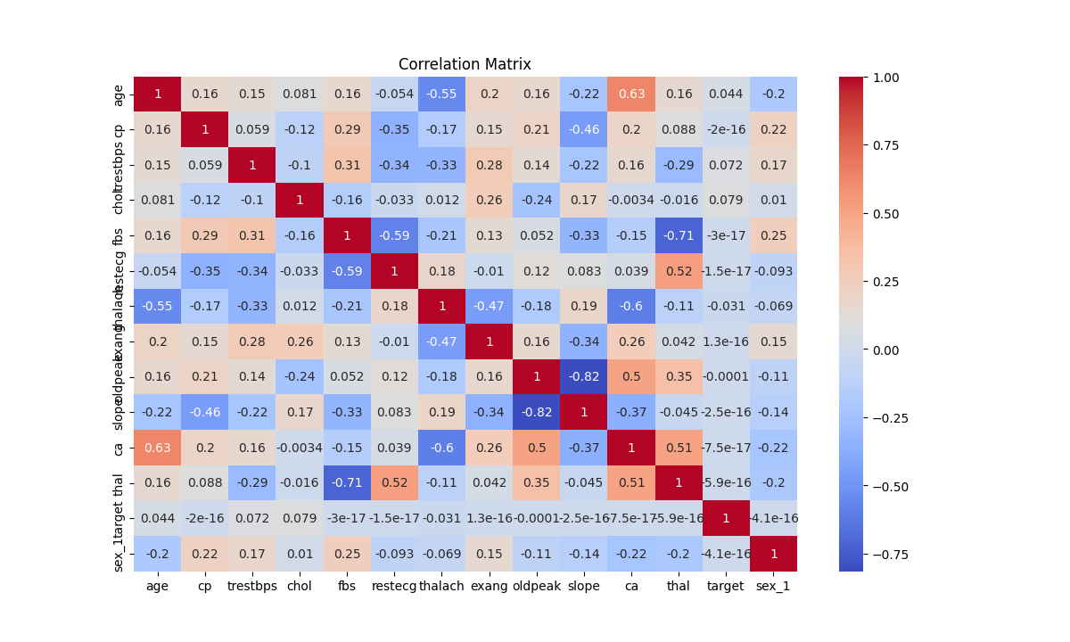

**2.**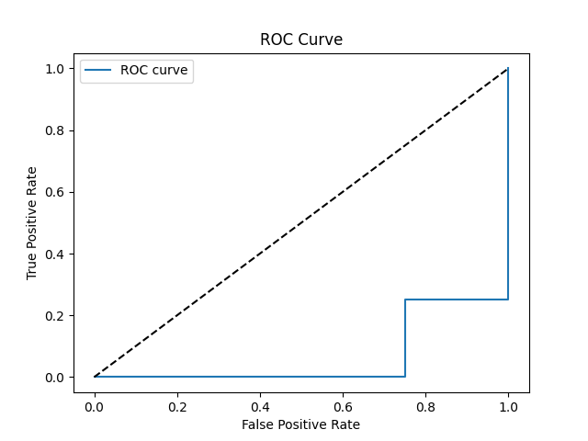

**3.**

